GARY W. CASE
AND COMPANY, INC.
AVAILABLE
FOR LEASE
WAREHOUSE SPACE

- Location: 1119 Cottonwood Rd.
Lynchburg, VA (Bedford County)

- Building #1: 12,000 Sq. Ft.
Four (4) Units – 3,000 Sq. Ft.
Three (3) with Loading Dock
One (1) with Drive-In Door
37.5’ x 80’

 Building #6: 6,900 Sq. Ft.
Six (6) Units – 1,150 Sq. Ft.
23’ x 50’
Drive-In Doors

 Zoning: I-2 (Higher Intensity Industrial District)

- Notes: New Metal Building
Great Location: Located off Lakeside Drive near
Overstreet Hardware

 Rent: $9.00 Sq. Ft./Yr.
3,000 Sq. Ft. - $2,250.00 a month
1,150 Sq. Ft. – $862.50 a month

FOR ADDITIONAL INFORMATION PLEASE CONTACT:

307 Brook Park Place
Forest, VA 24551
OFFICE: (434) 847 – 6692 • CELL: (434) 610 – 6692
E-MAIL ADDRESS: gary@garycaseco.com

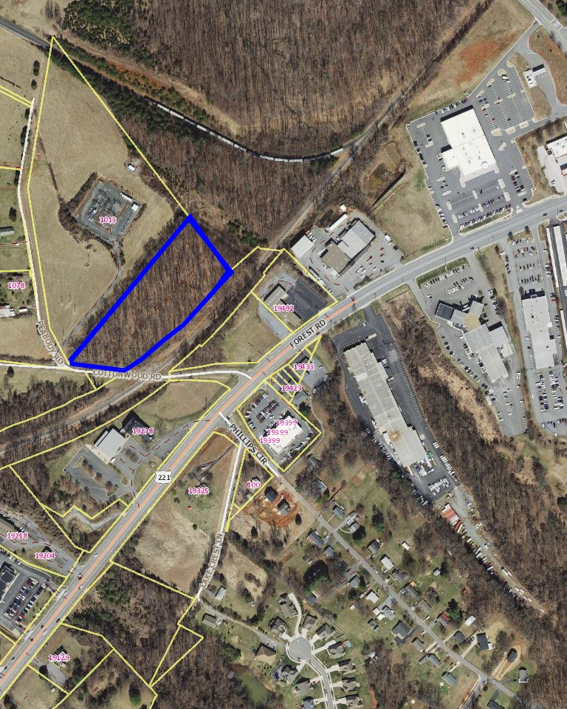

1119 Cottonwood Rd.
Lynchburg, VA

